***S.KEERTHANA 22BEC1503***

***AIM:***

To perform transient analysis of a MOSFET differential amplifier using LTSpice software.

***APPARATUS REQUIRED:***

LTSpice software updated with latest one.

***THEORY:***

A MOSFET (Metal-Oxide-Semiconductor Field-Effect Transistor) differential amplifier is a fundamental component in analog electronics, widely used in applications like operational amplifiers and signal processing circuits. This amplifier configuration employs a pair of MOSFETs, typically N-channel devices, connected in a balanced manner. It amplifies the voltage difference between two input signals while rejecting common-mode signals (signals present on both inputs). The key components include the matched MOSFET pair, a current source for biasing, and load resistors to convert the differential current into voltage. The differential gain is determined by the transconductance of the MOSFETs and the load resistance, while the common-mode rejection ratio (CMRR) measures its ability to suppress common-mode signals. Proper biasing is crucial for stable and linear operation, making MOSFET differential amplifiers indispensable in various analog electronic circuits.

***PROCEDURE:***

* Build the circuit diagram of a differential transistor amplifier as shown below for the two circuits in LTSpice.
* Do transient analysis by setting stop time as 3 milliseconds. Analyse the graph between input and output.
* ***CIRCUIT SCHEMATIC:***

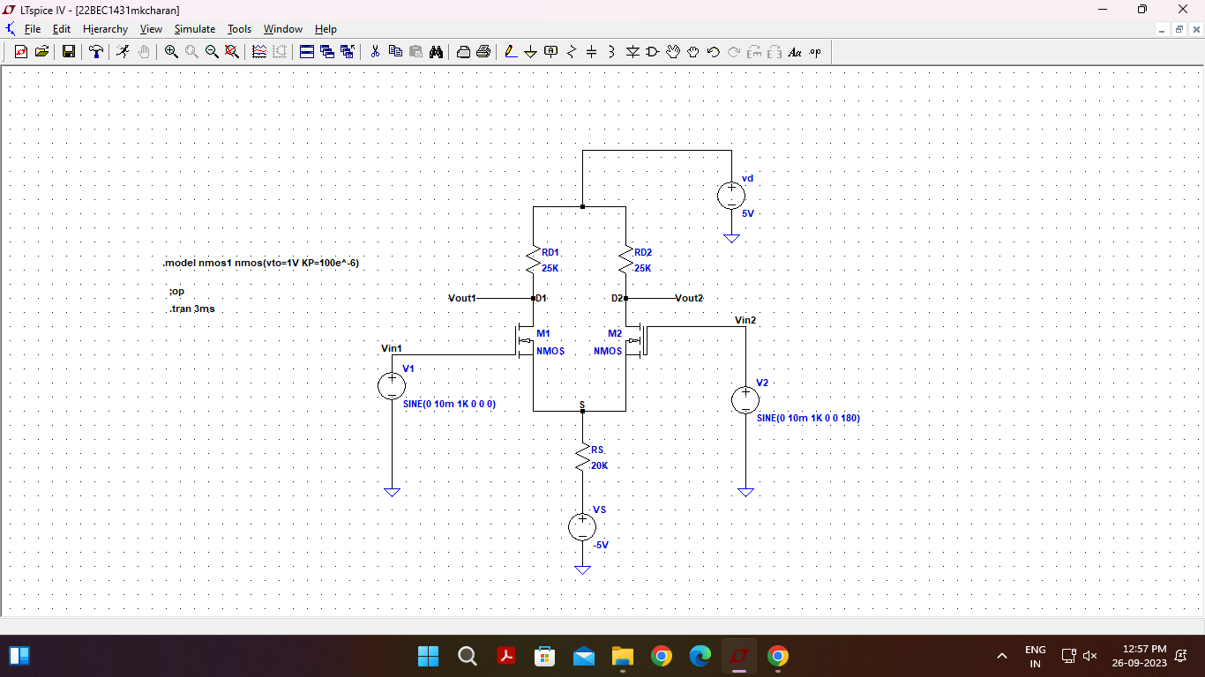

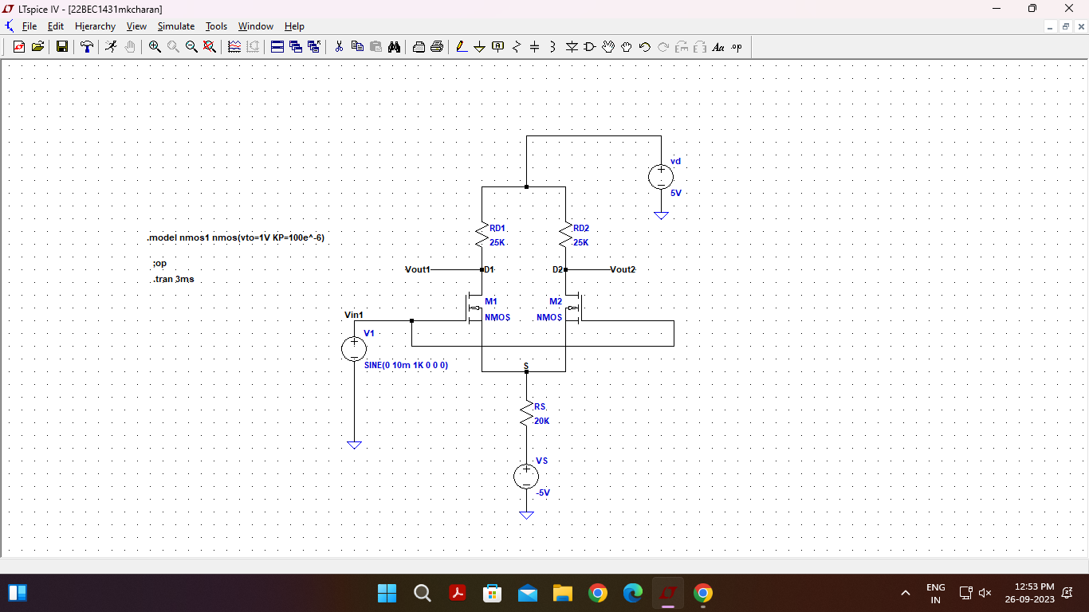

***SIMULATION COMMAND:***

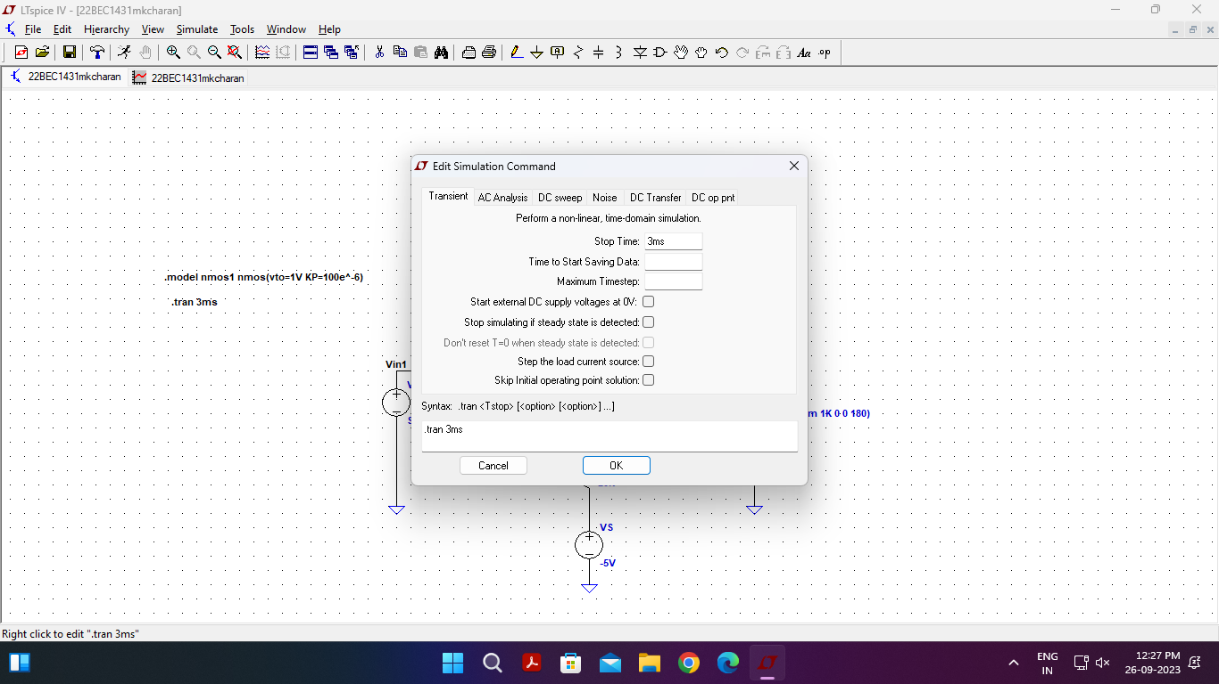

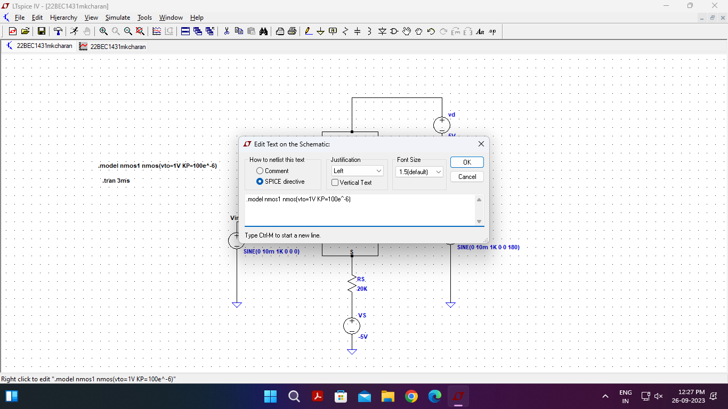

***SIMULATION OUTPUT WAVEFORM:***

* ***Dc operating point:***

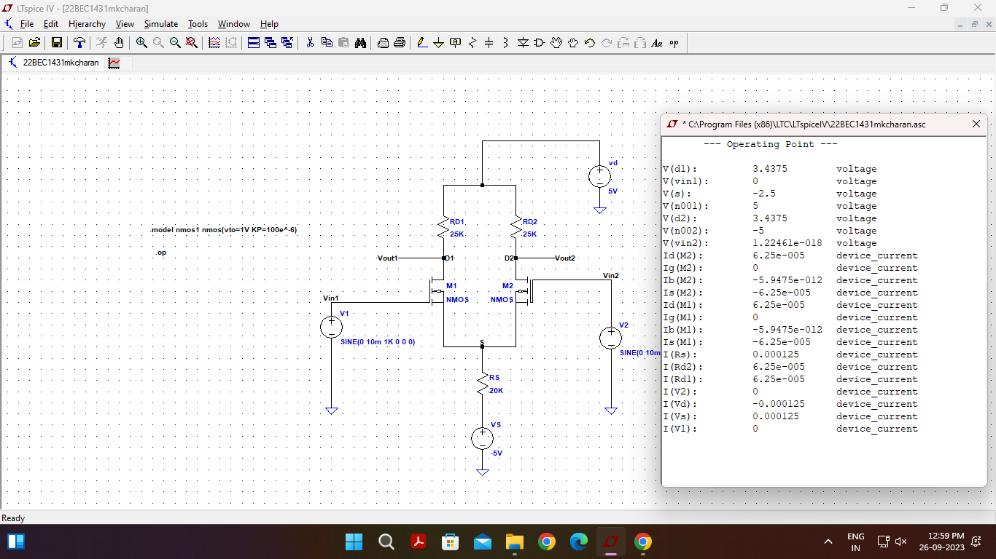

* ***For two input voltages(inverted output):***

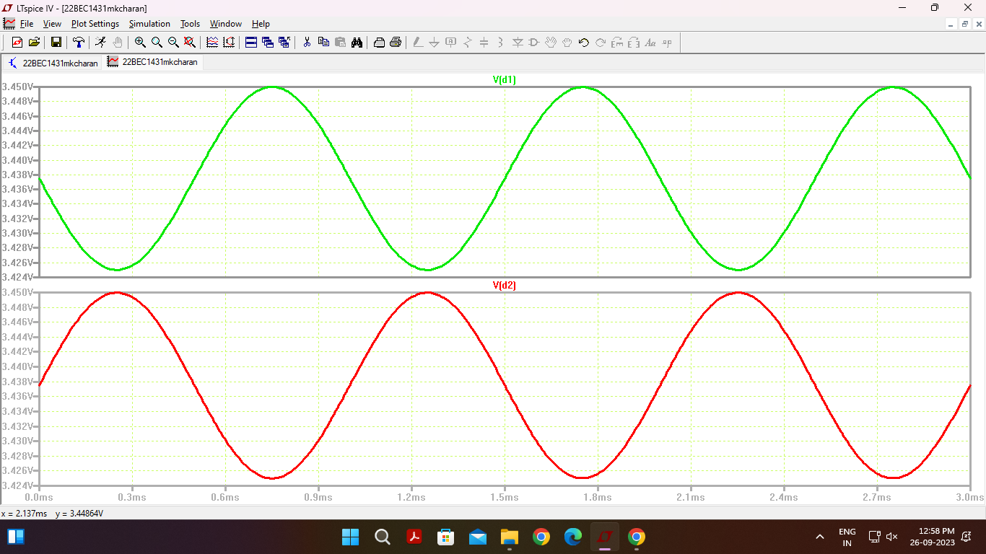

* ***For one input voltage(same output):***

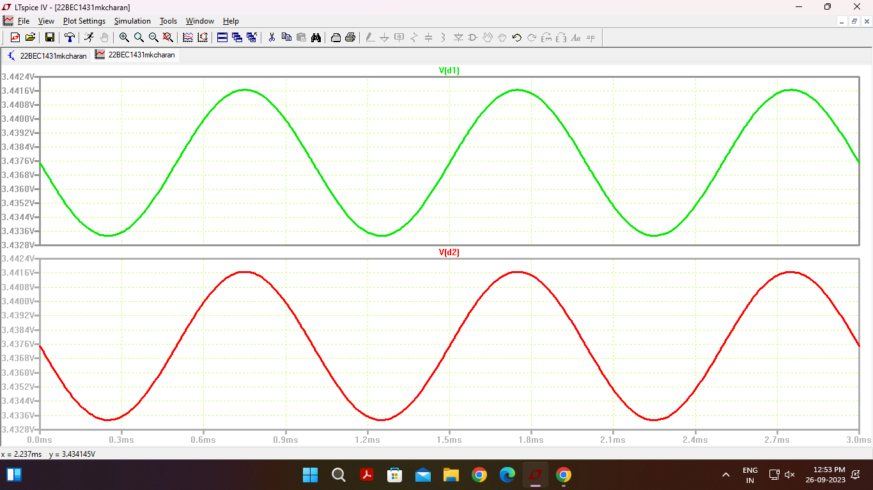

***RESULT:***

Hence the transient characteristics of a differential amplifier transistor is analysed and simulated using LTSpice software.

Phase shift observed in transient analysis is 180 degrees.